**Cleanup Process**

Date Set Characteristics

* Rows 240K rows
* Columns 29
* Size – 142 Mb

Fields provided

|  |
| --- |
| address |
| city_or_county |
| congressional_district |
| date |
| gun_stolen |
| gun_type |
| incident_characteristics |
| incident_id |
| incident_url |
| incident_url_fields_missing |
| latitude |
| location_description |
| longitude |
| n_guns_involved |
| n_injured |
| n_killed |
| notes |
| participant_age |
| participant_age_group |
| participant_gender |
| participant_name |
| participant_relationship |
| participant_status |
| participant_type |
| source_url |
| sources |
| state |
| state_house_district |
| state_senate_district |

* Not all fields were required. At the same time a lot of them had null values. We ran test to ensure we get maximum data for the graphs that we can

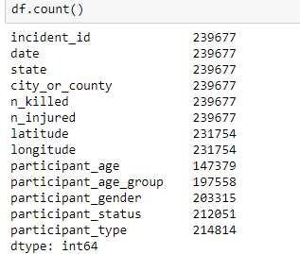

The top 8 fields in this had full data that we can use. After that the null values increase and the we loose a lot of data. Hence we decided to split up the data into smaller files vertically. This would allow us to work parallelly and not have to deal with a huge file.

Selection Set 1

fields=['incident_id',

'date',

'state',

'city_or_county',

'n_killed',

'n_injured','latitude',

'longitude', 'participant_age',

'participant_age_group',

'participant_gender',

'participant_status',

'participant_type']

df=pd.read_csv(file,usecols=fields)

df.head(12)

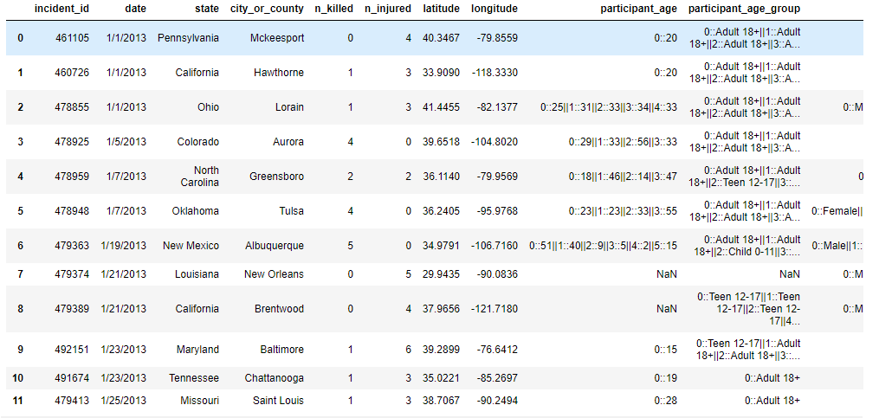

Selection set 2

inc_dt_region_df = df[['incident_id', 'date','state','city_or_county','n_killed','n_injured']].copy()

inc_dt_region_df.head()

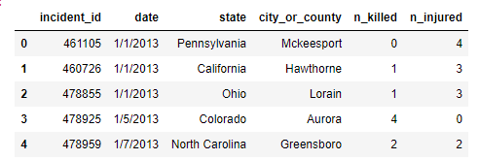

Selection set 3

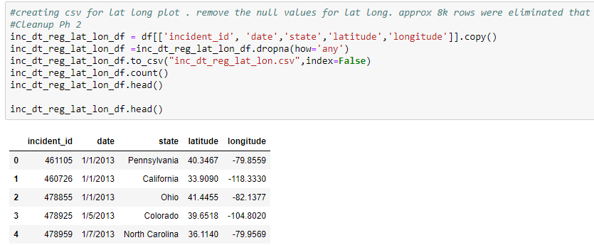

Three Sets of files allowed all of the members to get working in parallel

Age Cleanup and creating rows

The age column had multiple people ages in one row as it was based on per incident

In order to break this to multiple rows and get each age for that incident in one row , code had to be written

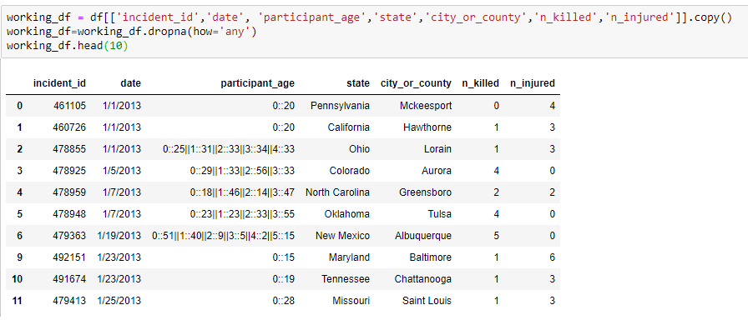

The same issue with Gender

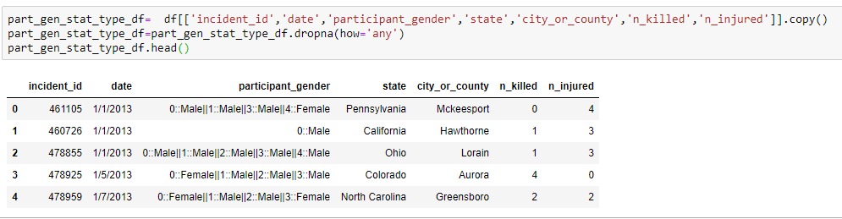

A cleanup of break up was required and this is how it looked after cleanup for the gender

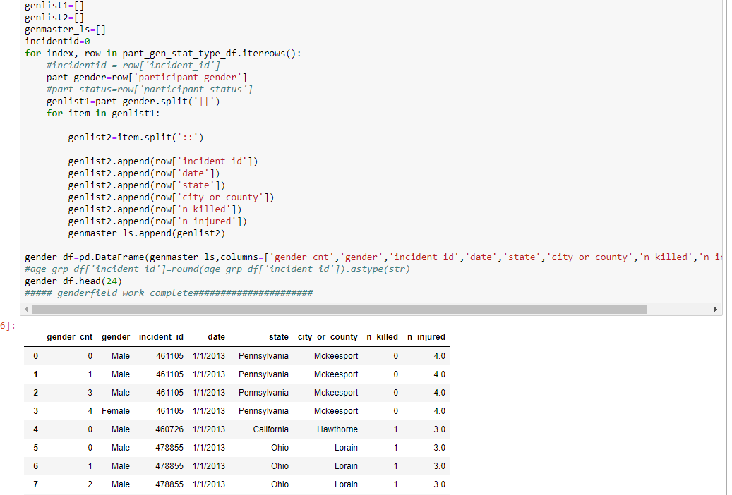

Gender and the age frames were merged to from a working frame

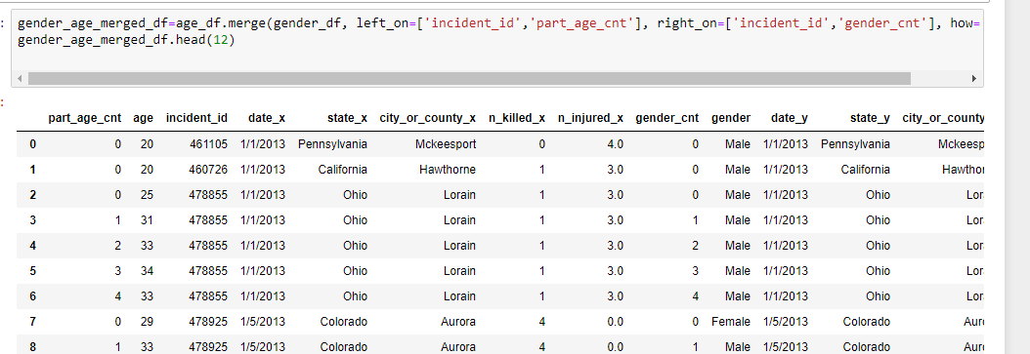

The next file was the state population that had to be cleaned up as it had an extra header and extra footer

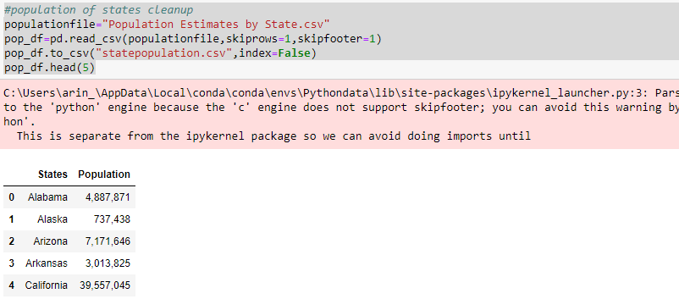

The third and final file also had extra rows that needed removal from top and bottom

